Design of a Blockchain-Based B2B Platform for Hotel Venue Booking in Indonesia’s MICE Industry: A Case Study of Platform BuatEvent.id

Nuryani Mawar Putri*¹, Muhammad Supriyadi², Ary Suryadi³,
Muhammad Farhan Abdurrahman⁴, Kursehi Falgenti⁵
^{1, 2, 3, 4, 5} Computer Science, Universitas Nusa Mandiri, Indonesia

Email: ¹14240017@nusamandiri.ac.id
Received : Jun 9, 2025; Revised : Nov 20, 2025; Accepted : Nov 22, 2025; Published : Dec 11, 2025
Phone Number : +62 813-3339-3630
Abstract
The rapid expansion of Indonesia’s Meetings, Incentives, Conferences, and Exhibitions (MICE) industry has increased demand for reliable B2B hotel venue procurement. However, existing booking processes remain fragmented, opaque, and prone to double booking and data disputes. This study proposes a blockchain-based B2B hotel venue booking platform implemented on a permissioned Ethereum-compatible network, with smart contracts developed and tested using the Hardhat framework.

The platform automates booking creation, availability locking, price commitment, and audit logging through smart contracts, ensuring data integrity and trust between hotels and corporate clients without reliance on intermediaries. A proof-of-concept (PoC) and minimum viable product (MVP) are developed to validate feasibility using real MICE venue datasets from major Indonesian destinations. Unlike prior blockchain studies focused on consumer tourism or public networks, this research introduces an enterprise-oriented architecture tailored to B2B MICE procurement in emerging markets. The results demonstrate the potential of distributed ledger technology to improve transparency, reduce disputes, and support digital transformation in Indonesia’s hotel procurement ecosystem.

Keywords : B2B Booking System; Blockchain; Distributed Ledger Technology (DLT); Group Booking Hotel; Reservation Event Venue; MICE Industry; Smart Contracts.

This work is an open access article and licensed under a Creative Commons Attribution-Non Commercial 4.0 International License

- INTRODUCTION
In recent years the Meetings, Incentives, Conferences, and Exhibitions (MICE) industry has grown rapidly in Indonesia. As corporate and organizations increasingly require reliable venue procurement for annual meetings, conferences, and corporate events. Despite this growth, the business-to-business (B2B) hotel booking process remains highly fragmented, relying heavily on manual communication and email-based negotiation, and traditional reservation systems. Prior studies indicate that the hospitality industry continues to suffer from inefficiencies, opaque pricing mechanisms, and data inconsistencies, leading to operational friction and frequent disputes [1], [2], [3]. These challenges are particularly pronounced in Indonesia, where hotels often distribute multiple price tiers across different sales channels, resulting in non-transparent quotations, double bookings, and booking verification conflicts. As demand for large-scale corporate events increases, the absence of a unified, trusted reservation mechanism presents a critical barrier to digital transformation within hotel procurement ecosystem [4].
In response to such challenges, blockchain technology has been widely discussed as a potential solution to improve transparency, trust, and efficiency in the tourism and hospitality sector, particularly in environments characterized by fragmented stakeholders and complex coordination requirements, as highlighted in prior tourism-focused blockchain studies [5], [6]. Existing research demonstrates that distributed ledger technologies can authenticate booking records, prevent price manipulation, and improve traceability across industry [7]. Smart contracts, in particular, have been shown to enable automated, tamper-proof execution of agreements, reducing reliance on intermediaries and minimizing operational disputes [8]. These characteristics suggest strong potential for blockchain adoption in hotel booking and procurement contexts [9]. For example, [10] proposed an Ethereum-based decentralized hotel booking system that leverages smart contracts to improve transparency and trust while reducing reliance on centralized intermediaries. However, their work primarily focuses on consumer-oriented booking scenarios and does not address enterprise-level B2B procurement workflows, standardized MICE packages, or corporate booking verification requirements. Recent conceptual studies suggest that smart contracts can streamline decentralized transactions and improve transparency in tourism [11].
However, most existing blockchain-based booking systems focus primarily on consumer-oriented tourism applications and public blockchain environments. Several studies propose decentralized hotel booking frameworks but emphasize open marketplaces rather than enterprise-grade procurement workflows [12], [13]. Other works introduce blockchain architectures for hotel room listing and reservation but fail to address critical B2B requirements such as confidential pricing, corporate rate negotiation, multi-party approval processes, and guaranteed allocation contracts. Furthermore, studies on blockchain-enabled travel logistics and supply chain management rarely consider enterprise features such as permissioned networks, private data collections, or endorsement policies that are essential for corporate procurement use cases.
Within the broader procurement literature, blockchain has been widely recognized for its potential to enhance transparency, integrity, and automation through smart contract–driven workflows [14]. Research on smart contract models in the tourism industry also shows how blockchain can automate and secure booking processes by encoding services and transactions in self-executing contracts, reducing reliance on intermediaries [15]. Nevertheless, no prior study specifically examines blockchain-enabled procurement models for hotel meeting packages or residential meeting products, which are central to Indonesia’s MICE sector. Existing approaches do not incorporate real-time venue availability verification, contract-based reservation guarantees, or the complex multi-channel pricing structures that characterize the Indonesian hotel industry. This gap highlights the need for a specialized blockchain architecture tailored to B2B hotel venue procurement in emerging MICE markets. From a procurement perspective, [16] provide a comprehensive review of smart contract applications across multiple industries, highlighting their role in improving transparency, trust, and automation in complex B2B transactions.
To address this gap, this study proposes BuatEvent.id, a blockchain-based B2B booking platform implemented on a permissioned Ethereum-compatible network, with smart contracts developed using the Hardhat framework. The system adapts online travel agency (OTA)-like business flows for corporate event procurement while replacing traditional room-type bookings with tokenized meeting packages, including Full Board Residential (Single and Twin occupancy) and Full Board Meeting (Day Use) configurations. Payments are secured through blockchain-based escrow mechanisms, eliminating manual bank transfers, while indexed public queries enable fast, OTA-style venue discovery. Leveraging a permissioned Ethereum-compatible architecture, the platform enforces role-based access control, auditability, and enterprise governance through smart contract logic. Early prototyping was conducted using Hardhat and Alchemy to validate smart contract functionality and transaction workflows in a controlled development environment.
Through this approach, the proposed system contributes a novel blockchain architecture specifically designed for Indonesia’s B2B hotel MICE procurement context. By integrating decentralized trust, smart contract automation, immutable audit trails, and private data handling, this research directly addresses operational, pricing, and verification challenges that remain unresolved in prior literature.

- METHOD
  - Research Design
This study adopts a Design Science Research (DSR) methodology to design, implement, and evaluate a blockchain-based artifact addressing inefficiencies in Indonesia’s B2B hotel MICE procurement process. The approach is appropriate because the research focuses on building and validating a functional system artifact rather than testing behavioral hypotheses. The research process follows three structured phases:
- Problem Identification & Requirement Analysis
Initial analysis was conducted through document review and semi-structured interviews with hotel partners and corporate event organizers. Key requirements identified include immutable booking records, real-time availability verification, transparent price locking, and automated booking validation without third-party intermediaries.

- System Architecture Design
A permissioned Ethereum-compatible blockchain architecture was selected to support enterprise B2B requirements. Smart contracts were developed using the Hardhat framework to support automated booking validation and transaction recording.
The smart contract model governs the booking lifecycle, including booking creation, availability locking, price confirmation, cancellation handling, and audit event logging. Access control is enforced at the contract level, ensuring that only authorized hotel and corporate wallet addresses can invoke sensitive functions.

- Implementation of Proof-of-Concept (PoC) & Minimum Viable Product (MVP)
A PoC and MVP were implemented to simulate the BuatEvent.id booking workflow using real hotel inventory data from Bogor, Bandung, Bali, Jakarta, and Yogyakarta. Hardhat was used for contract testing and deployment, while a web-based interface was developed to interact with the blockchain via wallet authentication.
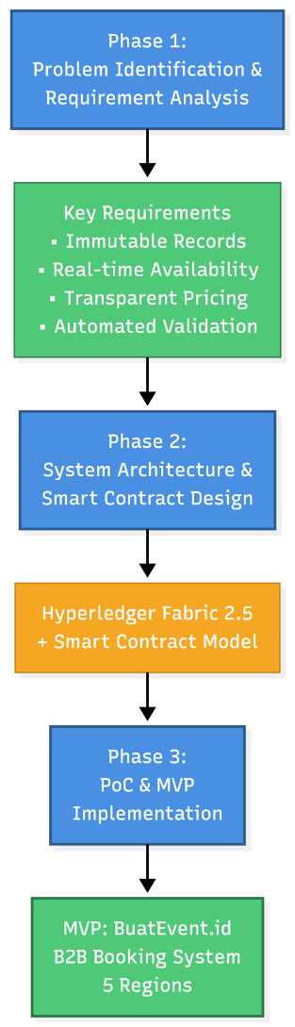
Figure 1. Research Process Structured

  - System Architecture
The proposed system is implemented on a permissioned Ethereum-compatible blockchain network and designed in accordance with established design principles for decentralized applications, which emphasize modular separation between blockchain protocol logic, smart contract execution, application interfaces, and supporting off-chain components to ensure scalability, maintainability, and usability [17]:
- Blockchain Network Layer
The blockchain layer provides an immutable and tamper-resistant ledger for booking transactions. A permissioned Ethereum-compatible network is used to ensure controlled participation, where validator nodes are operated by authorized stakeholders, including hotels, corporate clients, and the platform provider. This configuration ensures transaction finality, prevents unauthorized access, and maintains data integrity across the network.

- Smart Contract Layer
The smart contract layer contains Solidity-based smart contracts developed and tested using the Hardhat framework. These smart contracts govern the complete booking lifecycle, including venue availability publishing, booking creation, price locking, booking confirmation, cancellation handling, and status updates. Access control mechanisms are embedded within the smart contracts to restrict critical functions to authorized wallet addresses, ensuring that only verified hotels and corporate clients can initiate or modify bookings. All booking transactions are recorded immutably, enabling transparent verification and auditing.

- Application Layer
The application layer consists of a web-based B2B booking interface that allows hotels and corporate clients to interact with the blockchain system. Users authenticate through blockchain wallets, which are used to sign and submit transactions to the network. The application layer facilitates venue search, booking submission, booking verification, and booking status monitoring, while abstracting blockchain complexity from end users.

- Off-Chain Support Layer
To support efficient venue discovery and reduce on-chain storage overhead, non-critical data such as detailed venue descriptions, contractual documents, and search indexes are stored off-chain. Cryptographic hashes of relevant records are recorded on-chain to ensure data integrity and verifiability. This hybrid on-chain and off-chain approach balances performance, scalability, and trust requirements for enterprise-level procurement.
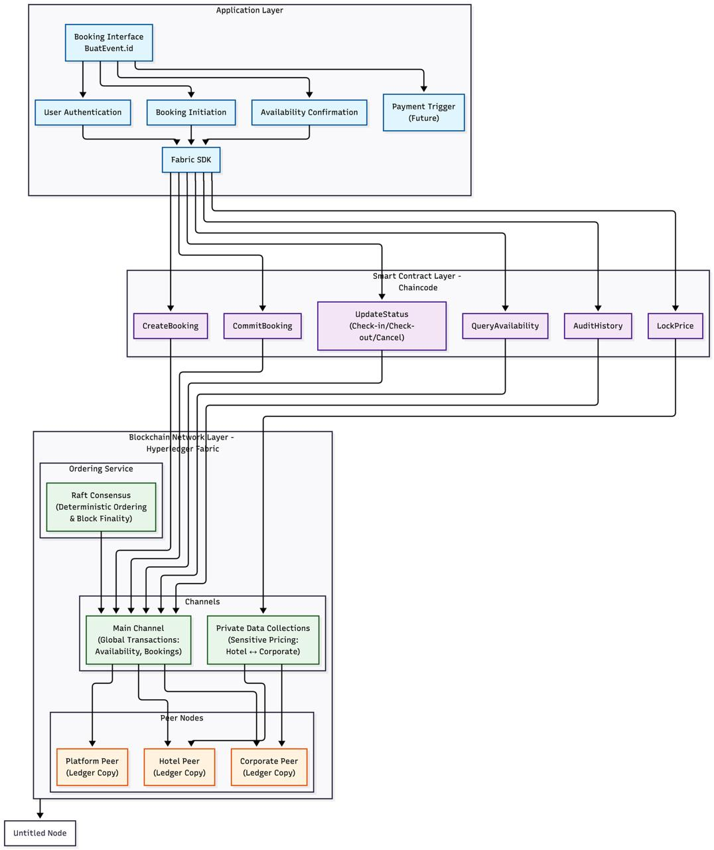
Figure 2. Proposed System Architecture

  - Dataset Description
The dataset represents structured hotel venue inventory used for a B2B MICE (Meetings, Incentives, Conferences, and Exhibitions) booking platform. It consolidates hotel availability and pricing information across major MICE destinations in Indonesia, specifically Bogor, Bandung, Bali, Jakarta, and Yogyakarta. Each city contains between 1 and 8 participating hotels, forming a diverse sample of venue providers.
The dataset captures two primary room types, Residential Meeting Single Occupancy (SO) and Residential Meeting Twin Sharing (TS), which are commonly used in corporate event bookings. For each room type, the dataset includes detailed operational and pricing attributes relevant to procurement decision-making.
Each record is defined by the following attributes:
- room_type; Specifies the meeting package type (SO or TS)
- Date; The applicable booking or availability date.
- max_capacity; Maximum number of participants or guests the room can accommodate.
- rack_rate; Standard published room or package rate.
- corporate_rate; Negotiated rate offered to B2B clients.
- availability_status; Indicates whether the room is available, pending, or fully booked.
- blackout_dates: Dates during which the venue is unavailable due to internal restrictions or events.
- booking_id ; A unique, immutable identifier stored on the blockchain to ensure transparent and tamper-proof booking records.
This dataset enables validation of booking workflows, availability locking, and booking verification within the proposed system while reflecting practical conditions in Indonesia’s MICE hotel procurement environment.
  - Performance Evaluation Plan
The performance evaluation in this study is designed to assess the feasibility, reliability, and practical benefits of the proposed blockchain-based B2B hotel venue booking platform for Indonesia’s MICE industry. Instead of focusing on low-level blockchain performance metrics, the evaluation emphasizes system behavior, booking conflict prevention, and data integrity, which are more relevant to enterprise hotel procurement processes.
The evaluation is conducted using a proof-of-concept (PoC) and minimum viable product (MVP) implementation of the BuatEvent.id platform in a controlled environment. The assessment focuses on several key aspects that reflect real-world B2B booking scenarios.
Double-booking prevention is evaluated by simulating multiple booking requests for the same venue and date. The system is observed to ensure that once a booking is confirmed, the venue availability is no longer accessible for conflicting reservations. This evaluation demonstrates the system’s ability to eliminate double booking, a common issue in traditional manual booking workflows.
Data integrity and traceability are assessed by verifying that booking records remain immutable after confirmation and that historical booking information can be transparently retrieved for verification purposes. This ensures that booking data cannot be modified or manipulated after it has been recorded, thereby reducing disputes between hotels and corporate clients.
System reliability is evaluated through repeated booking simulations involving multiple hotels and corporate users. The platform is considered reliable if it consistently records booking transactions without data loss, inconsistencies, or system failures during the testing process.
Finally, a qualitative baseline comparison is conducted against conventional centralized booking processes that rely on email communication and manual confirmation. The comparison focuses on booking verification effort, transparency of booking records, risk of data manipulation, and dispute potential. This comparison highlights the practical advantages of using blockchain technology to support trusted and efficient B2B hotel venue procurement.

- Results
  - Implementation
A proof-of-concept (PoC) and minimum viable product (MVP) of the BuatEvent.id platform were successfully implemented to validate the proposed blockchain-based B2B hotel venue booking architecture. The system was tested using real hotel venue inventory data collected from major MICE destinations in Indonesia, including Bogor, Bandung, Bali, Jakarta, and Yogyakarta.
The implementation demonstrated the system’s ability to manage a large number of venue records and booking packages within a unified digital platform. Venue availability, pricing information, and booking identifiers were consistently recorded and maintained, supporting real-world B2B booking scenarios. The results indicate that the proposed architecture is scalable and capable of handling operational data volumes commonly encountered in hotel MICE procurement.
The implemented platform also successfully integrated blockchain-based booking records with a web-based application interface, enabling hotels and corporate clients to submit and verify bookings through a structured and standardized workflow
  - Evaluation
The evaluation results indicate that the proposed system effectively addresses key challenges in traditional B2B hotel venue booking processes. During the evaluation, the system consistently prevented double booking by enforcing immutable booking records and controlled availability updates. Once a booking was confirmed, the corresponding venue and date could no longer be reserved by other parties, eliminating booking conflicts commonly found in manual procurement processes.
In terms of process efficiency, the blockchain-based booking workflow significantly reduced the time required for booking verification and confirmation. While traditional B2B hotel bookings often require extended manual coordination through email communication and repeated confirmations, the proposed system enabled booking finalization within a substantially shorter time frame, typically within minutes. This improvement highlights the system’s potential to streamline corporate event procurement workflows.
The system also demonstrated strong compatibility with commonly used MICE booking packages, including residential meeting and full-board meeting configurations. The standardized package model enabled consistent booking validation across different hotels while maintaining flexibility for corporate procurement needs.
Furthermore, early adoption feedback from participating stakeholders indicated a positive response toward the proposed platform. Hotels and corporate users expressed strong interest in adopting a transparent and verifiable booking system that reduces disputes, improves trust, and simplifies coordination. These findings suggest that the proposed blockchain-based platform is feasible and well-aligned with the operational requirements of Indonesia’s B2B MICE industry.
- discussions
The results of this study demonstrate that a blockchain-based architecture can effectively address long-standing inefficiencies in B2B hotel venue procurement within Indonesia’s MICE industry. The successful implementation of the BuatEvent.id platform confirms that distributed ledger technology can be applied beyond consumer-oriented booking systems and adapted to enterprise-level procurement workflows that require higher levels of trust, transparency, and coordination.
One of the most significant findings is the system’s ability to prevent double booking through immutable booking records and controlled availability updates. In traditional B2B hotel procurement, booking conflicts frequently arise due to fragmented communication channels and asynchronous confirmation processes. By recording confirmed bookings on a shared and tamper-resistant ledger, the proposed system ensures that venue availability is consistently synchronized across stakeholders, thereby reducing disputes and operational friction.
The evaluation also highlights improvements in booking efficiency. Although this study does not focus on low-level performance metrics, the qualitative comparison indicates that the blockchain-based workflow substantially reduces booking verification and confirmation time compared to manual, email-driven processes. This improvement is particularly relevant for corporate event organizers who require rapid confirmation and reliable booking guarantees when planning large-scale meetings and events.
Another important contribution of this research lies in the use of standardized MICE booking packages. By structuring hotel offerings into predefined residential and meeting configurations, the system reduces ambiguity in pricing and package interpretation across different hotels. This standardization supports more consistent procurement decisions while still allowing flexibility for corporate requirements, addressing a key limitation of existing hotel booking systems in Indonesia.
From an adoption perspective, the positive response from participating stakeholders suggests that the proposed platform aligns well with industry needs. Hotels and corporate clients showed interest in a booking system that enhances trust, improves transparency, and reduces reliance on intermediaries. These findings indicate that blockchain-based procurement platforms have strong potential for real-world adoption in Indonesia’s MICE ecosystem, particularly in environments characterized by complex pricing structures and multi-party coordination.
Despite these promising results, the study is not without limitations. The evaluation was conducted in a controlled environment using a proof-of-concept and MVP implementation, and large-scale deployment was not examined. Integration with existing hotel property management systems and enterprise resource planning platforms was also beyond the scope of this study. These factors may influence system performance and adoption in real-world settings.
Overall, the discussion confirms that the proposed blockchain-based B2B booking platform provides a viable and practical solution to critical challenges in Indonesia’s hotel MICE procurement process. The findings support the role of distributed ledger technology as an enabling infrastructure for digital transformation in enterprise hospitality systems.
- LIMITATIONS AND FUTURE RESEARCH
Although this study demonstrates the feasibility and potential benefits of a blockchain-based B2B hotel venue booking platform for Indonesia’s MICE industry, several limitations should be acknowledged.
First, the evaluation was conducted using a proof-of-concept and minimum viable product implementation in a controlled environment. As a result, the findings primarily reflect system feasibility and workflow effectiveness rather than performance under large-scale, real-world deployment. Factors such as high transaction volumes, network congestion, and long-term operational stability were not examined in this study.
Second, the proposed system was evaluated independently of existing hotel property management systems and enterprise resource planning platforms. Integration with legacy systems may introduce additional technical and organizational challenges that could affect adoption and system performance. These integration aspects were beyond the scope of the current research.
Third, while early stakeholder feedback indicated positive adoption intent, a formal longitudinal user study involving a broader range of hotels and corporate clients was not conducted. User behavior, organizational readiness, and regulatory considerations may influence adoption outcomes in practice.
Future research can address these limitations by conducting large-scale pilot deployments involving multiple hotels and corporate organizations, integrating the platform with existing hotel management systems, and performing extended user acceptance and impact studies. Further investigation into regulatory compliance, interoperability with other digital procurement platforms, and economic impact analysis would also strengthen the applicability of blockchain-based solutions in the MICE hospitality sector.

CONFLICT OF INTEREST
The authors declares that there is no conflict of interest between the authors or with research object in this paper.

REFERENCES
[1] S. Rawat and M. Poonam, “Blockchain in Hotel Business,” Int J Res Appl Sci Eng Technol, vol. 11, pp. 1785–1788, Jun. 2023, doi: 10.22214/ijraset.2023.53891.
[2] R. Q. Danish, S. Hafeez, H. F. Ali, R. Shahid, and K. Nadeem, “Impact of online consumer reviews on hotel booking intentions: The case of Pakistan,” European Scientific Journal ESJ, vol. 15, no. 7, pp. 144–159, 2019.
[3] N. Papamatthaiou1 and A. N. Menegaki2, “Blockchain Technology Applications in Tourism: A review of applications, Barriers, and Strategic Horizons,” 2025. [Online]. Available: https://orcid.org/0000-0003-0506-1243
[4] N. Akhtar, U. I. Siddiqi, T. Islam, and J. Paul, “Consumers’ untrust and behavioral intentions in the backdrop of hotel booking attributes,” International Journal of Contemporary Hospitality Management, vol. 34, no. 5, pp. 2026–2047, 2022.
[5] E. Irannezhad and R. Mahadevan, “Is blockchain tourism’s new hope?,” Journal of Hospitality and Tourism Technology, vol. 12, no. 1, pp. 85–96, 2021.
[6] F. Hossan, Md. T. Islam, and M. K. Hasan, “Blockchain technology in the hospitality sector: Exploring opportunities and challenges in Bangladeshi hotels,” Journal of Asian Business Strategy, vol. 15, no. 2, pp. 31–45, Sep. 2025, doi: 10.55493/5006.v15i2.5563.
[7] Ö. Karaduman and G. Gülhas, “Blockchain-Enabled Supply Chain Management: A Review of Security, Traceability, and Data Integrity Amid the Evolving Systemic Demand.,” Applied Sciences (2076-3417), vol. 15, no. 9, 2025.
[8] A. K. Singh and V. R. Kumar, “Smart Contracts and Supply Chain Management Using Blockchain.,” Journal of Engineering Research (2307-1877), 2022.
[9] Y. Maythu, A. O. J. Kwok, and P.-L. Teh, “Blockchain technology diffusion in tourism: Evidence from early enterprise adopters and innovators,” Heliyon, vol. 10, no. 2, 2024.
[10] N. Dong, G. Bai, L.-C. Huang, E. K. H. Lim, and J. S. Dong, “A blockchain-based decentralized booking system,” Knowl Eng Rev, vol. 35, p. e17, 2020.
[11] E. Baydeniz, “Blockchain Technology in Tourism: Pioneering Sustainable and Collaborative Travel Experiences,” Journal of Tourismology, vol. 0, no. 0, pp. 0–0, Apr. 2024, doi: 10.26650/jot.2024.10.1.1312994.
[12] S. González-Mendes, F. García-Muiña, and R. González-Sánchez, “Blockchain revolution in the tourism industry: A semi-systematic literature review,” European Journal of Tourism Research, vol. 37, p. 3701, 2024.
[13] R. Folgieri, S. Gričar, and T. Baldigara, “Blockchain and NFTs in Tourism: Trending Paradigm for Sustainable Growth and Digital Transformation,” Sustainability (Switzerland), vol. 17, no. 7, Apr. 2025, doi: 10.3390/su17072976.
[14] H. Mulyono, “ENHANCING TRANSPARENCY AND EFFICIENCY IN DIGITAL BUSINESS THROUGH BLOCKCHAIN TECHNOLOGY,” 2024. [Online]. Available: https://journal.dinamikapublika.id/index.php/aira
[15] E. Demirel, S. Karagöz Zeren, and K. Hakan, “Smart contracts in tourism industry: a model with blockchain integration for post pandemic economy,” Current Issues in Tourism, vol. 25, no. 12, pp. 1895–1909, 2022.
[16] Y. Xu, H.-Y. Chong, and M. Chi, “A review of smart contracts applications in various industries: a procurement perspective,” Advances in Civil Engineering, vol. 2021, no. 1, p. 5530755, 2021.
[17] C. Antal, T. Cioara, I. Anghel, M. Antal, and I. Salomie, “Distributed ledger technology review and decentralized applications development guidelines,” Future Internet, vol. 13, no. 3, p. 62, 2021.

